Practical: 5 | Implementation of a knapsack problem using dynamic programming.
/08/2026

Aim: To Implement the knapsack problem using dynamic programming.
.

Algorithm:

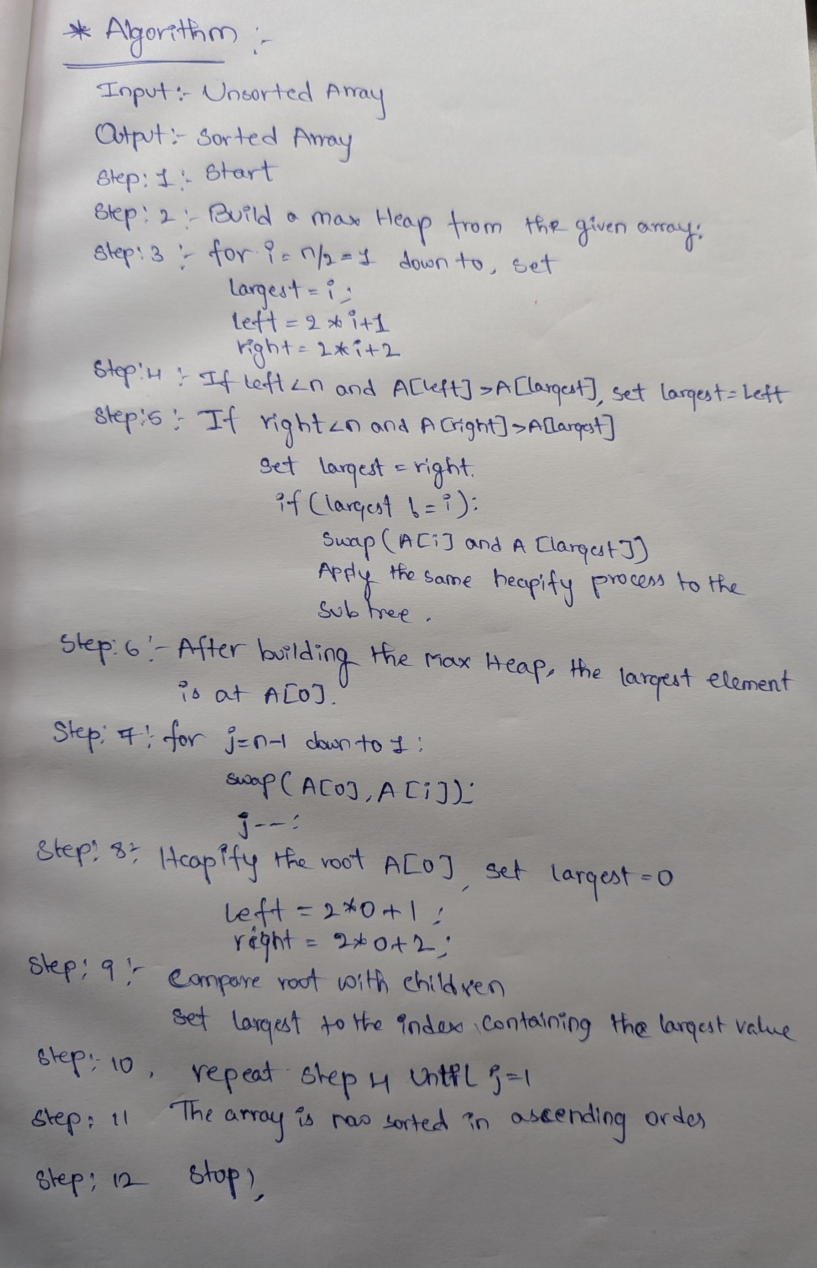

Program:

Max-heap sort algorithm
#include <iostream>
using namespace std;

void max_heapify(int arr[], int n, int i)
{
int largest = i;

int l = 2 * i + 1;
int r = 2 * i + 2;

// Check left child
if (l < n && arr[l] > arr[largest])
{
largest = l;
}

// Check right child
if (r < n && arr[r] > arr[largest])
{
largest = r;
}

// If largest is not the root
if (largest != i)
{
int t = arr[i];
arr[i] = arr[largest];
arr[largest] = t;

// Heapify the affected subtree
max_heapify(arr, n, largest);
}
}

void heapSort(int arr[], int n)
{
// Build Max Heap
for (int i = n / 2 - 1; i >= 0; i--)
{
max_heapify(arr, n, i);
}

// Heap Sort
for (int j = n - 1; j > 0; j--)
{
// Move largest element to the end
int t = arr[0];
arr[0] = arr[j];
arr[j] = t;

// Heapify remaining heap
max_heapify(arr, j, 0);
}
}

void display(int arr[], int n)
{

for (int i = 0; i < n; i++)
{
cout << arr[i] << " ";
}

cout << endl;
}

int main()
{
int arr[] = {5, 6, 9, 7, 6, 56};
cout<<"/------------------- max heap sort----------------/"<<endl;
int size = sizeof(arr) / sizeof(arr[0]);
cout << "Unsorted array: ";
display(arr, size);

heapSort(arr, size);

cout << "Sorted array: ";
display(arr, size);

return 0;
}

Output:

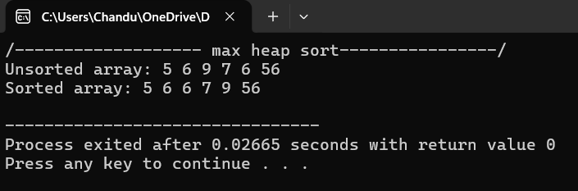

Time Complexity:

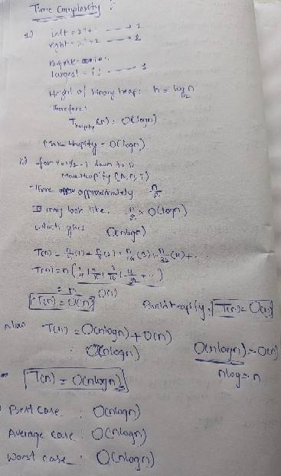

Conclusion:
The Implementation of max-heap sort algorithm and the program of the max-heap sort Successfully got executed.
The time complexities of the max-heap sort algorithm in three cases best, average, worst is O(nlogn).

